**Brainstorm**

**TIP**

You can select a sticky note and hit the pencil [switch to sketch] icon to start drawing!

**& idea prioritization**

**RETAILSTORE STOCKINVENTORY ANALYTICS**

**10 minutes** to prepare

**1 hour** to collaborate

**2-8 people** recommended

Detect the various type of stock needed

Create multiple analysis graphs

lack of inventory leads to major loss

## Before you collaborate

A little bit of preparation goes a long way with this session. Here’s what you need to do to get going.

**10 minutes**

**A Team gathering**

Define who should participate in the session and send an invite. Share relevant information or pre-work ahead.

**B Set the goal**

Think about the problem you'll be focusing on solving in the brainstorming session.

**C Learn how to use the facilitation tools**

Use the Facilitation Superpowers to run a happy and productive session.

[**Open article**](https://support.mural.co/en/articles/2113740-facilitation-superpowers)

**1**

## Define your problem statement

What problem are you trying to solve? Frame your problem as a How Might We statement. This will be the focus of your brainstorm.

**5 minutes**

**PROBLEM**

To

**Key rules of brainstorming**

To run an smooth and productive session

**2**

## Brainstorm

Write down any ideas that come to mind that address your problem statement.

**10 minutes**

**S.VENKATESH**

# 

Details of stock should be

safe

Store should

Visited frequently

How much inventory should I carry?

**RAM KUMAR**

EOQ for optimal order quantities

**TIP**

Add customizable tags to sticky notes to make it easier to find, browse, organize, and categorize important ideas as themes within your mural.

# 

Understand

The data set

Unhappy

Customers

And a

Damaged

brand

Emamine

Gross

margin

**3**

**Group ideas**

Take turns sharing your ideas while clustering similar or related notes as you go. Once all sticky notes have been grouped, give each cluster a sentence-like label. If a cluster is bigger than six sticky notes, try and see if you and break it up into smaller sub-groups.

**20 minutes**

Track all sales receivables and purchase payables

Track all sales receivables and purchase payables

Practice 80/ 20 inventory rule

Just in time inventory control method

**4**

## Prioritize

Your team should all be on the same page about what's important moving forward. Place your ideas on this grid to determine which ideas are important and which are feasible.

**20 minutes**

Discount

lack of inventory leads to lost sales

Efficiency

Understand the Dataset

RETAIL

STORE

DATA

ANALYSIS

Create multiple analysis graphs/charts

Inventory turnover ratio

**After you collaborate**

You can export the mural as an image or pdf to share with members of your company who might find it helpful.

**Quick add-ons**

**A Share the mural**

**Share a view link** to the mural with stakeholders to keep them in the loop about the outcomes of the session.

**B Export the mural**

Export a copy of the mural as a PNG or PDF to attach to emails, include in slides, or save in your drive.

**Keep moving forward**

Create multiple analysis graphs/chart

**Strategy blueprint**

Define the components of a new idea or strategy.

[**Open the template**](https://app.mural.co/template/e95f612a-f72a-4772-bc48-545aaa04e0c9/984865a6-0a96-4472-a48d-47639307b3ca)

**Customer experience journey map**

Stay in topic. Defer judgment.

Tabulate Tangible Book Value

Minises

Out of

stocks

Live

Stack

reports

Encourage wild ideas. Listen to others.

**Importance**

Track all sales receivables and purchase payables

Track all sales receivables and purchase payables

Utilize open to buy(OTB) inventory planning

Real time FIFO cost management helping to track cost of raw materials,product accurately

Stock control for omnichannel retailin

If each of these

Understand customer needs, motivations, and

obstacles for an experience.

When you know key metrics, you can predict cash fow, inventory needs, and stafng needs

Avoiding

Over

stockage

[**Open the template**](https://app.mural.co/template/b7114010-3a67-4d63-a51d-6f2cedc9633f/c1b465ab-57af-4624-8faf-ebb312edc0eb)

Marketing

Detect the various type of stock needed

Go for volume. If possible, be visual.

tasks could get

done without any difficulty or cost, which would have the most positive impact?

**Strengths, weaknesses, opportunities & threats**

Identify strengths, weaknesses, opportunities, and threats (SWOT) to develop a plan.

[**Open the template**](https://app.mural.co/template/6a062671-89ee-4b76-9409-2603d8b098be/ca270343-1d54-4952-9d8c-fbc303ffd0f2)

Unhappy customers and a damaged brand

## VAIKHUNTH

**SRIRAM.G**

**TIP**

Participants can use their cursors to point at where sticky notes should go on the grid. The facilitator can confirm the spot by using the laser pointer holding the **H key** on the keyboard.

Inventory of product history management

Reduce the risk of stock in too little or too much on hand

Price

optimization

LocationAllocation accross multiple

warehouses

Back ordering fow that allows to issue

purchases directly from order of item you don't have in

Strength of

ecommerce sales

[**Share template feedback**](https://muralco.typeform.com/to/CiqaHVat?typeform-source=app.mural.co)

Live stock reports

Identifying

customers

Demand

prediction

Alert

Demand

stock

Identifying potential risks

Prevent

Over

Stock

Alert

Demand

stock

Keeping check over obsolescence and ensure control over movement of inventories

Verifed sellers and locate products

Unhappy customers and a damaged brand

Strength of

ecommerce sales

Short-term forecasting is so important in the retail and consumer goods industry

How much your customers are

spending per order

Understand the Dataset

Visit the Stores

Customer

Feedback

Details of stock should be safe

# 

Live stock reports

Categorization of products in stock

Real time dynmaic price list module

Season based product recommendation

[**Share template feedback**](https://muralco.typeform.com/to/CiqaHVat?typeform-source=app.mural.co)

**Feasibility**

Regardless of their importance, which tasks are more feasible than others? (Cost, time, effort, complexity, etc.)

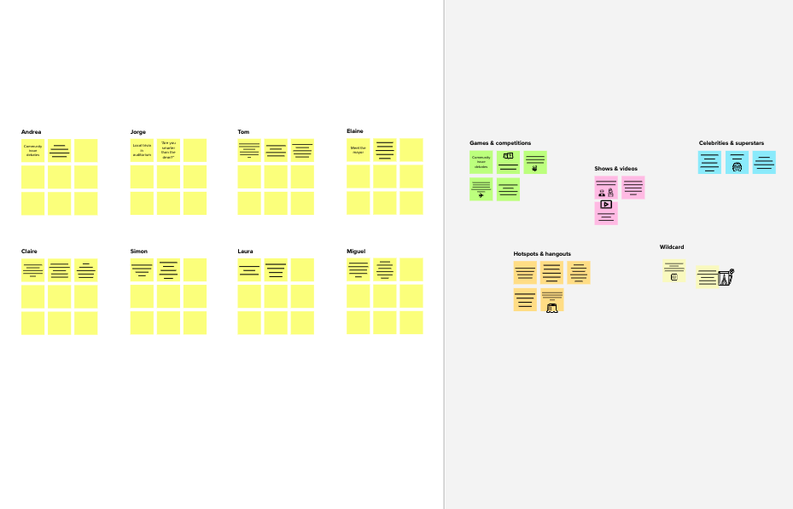

**Template**

**Need some inspiration?**

See a finished version of this template to kickstart your work.

[**Open example**](https://app.mural.co/template/e5a93b7b-49f2-48c9-afd7-a635d860eba6/93f1b98d-b2d2-4695-8e85-7e9c0d2fd9b9)